Event capture
graphical user interface

Patch Installation Guide



Software Version 2.0
Patch EC*2*112
June 2012

Department of Veterans Affairs
Office of Information and Technology (OIT)
Product Development

Table of Contents

1 Introduction 1
1.1 Purpose 1
1.2 Scope 1
1.3 Acronyms 1
2 Install Requirements 2
2.1 Package Integration 2
2.2 Server Requirements 2
2.3 Client Requirements 2
3 Server Installation 3
3.1 KIDS Installation Example 4
4 Client Installation 6
4.1 RPC Broker 6
4.2 Command Line Parameters 6
4.3 ECS GUI Client Installation 7
4.4 Accessing ECS GUI via CPRS 16

Introduction

Purpose
The purpose of this Installation Guide is to provide details on the installation of Event Capture System (ECS) software Graphical User Interface (GUI) for Patch EC*2.0*112. The intended audience includes Technical Services, National Veterans Health Information Systems and technology Architecture (VistA) Support and Software Quality Assurance.

Scope
The ECS FY12 Annual Enhancements project specifies enhancements to the current v2.0 Event Capture software application via patch EC*2*112 to collect additional information needed for cost and workload management reporting. In order to accomplish this objective, additional data will be added to the current software application to enhance current collection of data and the processes for streamlined data entry and reporting mechanisms. The Decision Support Office (DSO) has provided a high level list of requested changes or updates to the software for FY12. Examples of the changes include:
- Enhancements to the Social Security Number (SSN) Display
- Enhancements to the Event Code Screen
- Enhancements to the Event Capture Patient File
- Enhancements to the Event Capture Reports

Acronyms
Term | Definition
CPRS | Computerized Patient Record System
DD | Data Definitions
DSS | Decision Support System
DSO | Decision Support Office
EC | Event Capture
ECS | Event Capture System
GP | GUI Parameter
GUI | Graphical User Interface
KIDS | Kernel Installation & Distribution System
TM | Tool Menu
VA | Department of Veterans Affairs
VistA | Veterans Health Information Systems and Technology Architecture

Install Requirements

Package Integration
The following package versions (or higher) must be installed prior to loading this patch of EC:

Kernel 8.0
Toolkit 7.3
Event Capture 2.0
RPC Broker 1.1
MailMan 8.0
VA FileMan 22.0

Server Requirements
Any site not currently running the ECS application and wishing to install ECS GUI must install all previous EC patches. For details on how to install the previous EC patches, please refer to the corresponding patch descriptions and EC 2.0 Installation Guide.

Each user will also need to have the option EC GUI CONTEXT added to their secondary menu.

Client Requirements
ECS GUI may be run in a test environment before installation, but it is not necessary. EC runs on the standard hardware platforms used by Department of Veterans Affairs (VA) Healthcare facilities. These systems consist of VMS/Cache or Linux/Cache platforms.

To run this Delphi-based application, the following is recommended:

- Intel Pentium 90 or higher (P166 recommended)
- Microsoft Windows 98 or NT 4.0 with Service Pack 3 or later
- Memory: 32MB of RAM (64MB or more recommended)
- Hard disk space: 6MB
- VGA or higher resolution monitor
- Mouse or other pointing device
- Networks supported: Any Microsoft Windows 98, or Windows NT or higher compatible network

Note: Software that is wholly a local development effort (such as BA Loader, etc.) may not be compatible with Event Capture. Please verify compatibility prior to installation.

Server Installation
- Use the INSTALL/CHECK MESSAGE option on the PackMan menu to unload the KIDS distribution included with this message.

- Select the Installation menu from the Kernel Installation and Distribution System Menu.

- From this menu, you may elect to use the following options (when prompted for INSTALL NAME, enter EC*2.0*112):

  - Backup a Transport Global - this option will create a backup message of any routines exported with the patch. It will NOT backup any other changes such as DDs or templates.
  - Compare Transport Global to Current System - This option will allow you to view all changes that will be made when this patch is installed. It compares all components of this patch (routines, DD's, templates, etc.).
  - Verify Checksums in Transport Global - This option will allow you to ensure the integrity of the routines that are in the transport global.
  - Print Transport Global - this option will allow you to view the components of the KIDS build.

- Use the Install Package(s) option and select the package EC*2.0*112.

- When the prompt 'Want KIDS to Rebuild Menu Trees Upon Completion of
Install? NO////' appears, answer YES unless your system does this in a nightly TaskMan process. (NOTE: The new default for this question is NO)

- When the prompt 'Want KIDS to INHIBIT LOGONs during the install? NO////' appears, answer NO (unless otherwise indicated). (NOTE: The new default for this question is NO)

- When the prompt 'Want to DISABLE Scheduled Options, Menu Options, and Protocols? YES//' appears, answer YES (unless otherwise indicated).

- When the prompt 'Enter options you wish to mark as 'Out Of Order':' appears, enter the following options: EC GUI Context version 2.1.3.3 ... EC GUI CONTEXT

- When the prompt 'Enter protocols you wish to mark as 'Out Of Order':' appears, press <Enter>.

- Install the Event Capture GUI client software following the instructions of the EC GUI Installation Guide found on the VistA Documentation Library (VDL) at the following link: http://www.va.gov/vdl/application.asp?appid=39

The Event Capture GUI executable file "ECS GUI.exe", that is unbundled after running the install in step 10, may be copied to another machine without additional supporting files.

KIDS Installation Example
Select KIDS OPTION: INSTALL PACKAGE(S)
Select INSTALL NAME: EC*2.0*112 1/18/11@17:04:31
=> EC*2*112

This Distribution was loaded on Jan 19, 2011@17:04:31 with header of
EC*2*112

It consisted of the following Install(s):
EC*2.0*112

Checking Install for Package EC*2.0*112

Install Questions for EC*2.0*112

Incoming Files:

721 EVENT CAPTURE PATIENT
Note: You already have the 'EVENT CAPTURE PATIENT' File.

Want KIDS to Rebuild Menu Trees Upon Completion of Install? NO//

Want KIDS to INHIBIT LOGONs during the install? NO//
Want to DISABLE Scheduled Options, Menu Options, and Protocols? NO// YES

Enter options you wish to mark as 'Out Of Order': EC GUI CONTEXT EC GUI Context version 2.1.3.3

Enter options you wish to mark as 'Out Of Order':

Enter protocols you wish to mark as 'Out Of Order':

Delay Install (Minutes): (0-60): 0//

Enter the Device you want to print the Install messages.
You can queue the install by enter a 'Q' at the device prompt.
Enter a '^' to abort the install.

DEVICE: HOME//

Install Started for EC*2.0*112 :
Jan 19, 2012@06:49:43

Build Distribution Date: Jan 04, 2012

Installing Routines:...................
Jan 19, 2012@06:49:44

Installing Data Dictionaries: ...
Jan 19, 2012@06:49:44

Installing PACKAGE COMPONENTS:

Installing HELP FRAME......

Installing SECURITY KEY..

Installing OPTION..
Jan 19, 2012@06:49:44

Updating Routine file......

Updating KIDS files.......

EC*2.0*112 Installed.
Jan 19, 2012@06:49:44

Not a production UCI

NO Install Message sent
────────────────────────────────────────────────────────────────────────────────
┌────────────────────────────────────────────────────────────┐
100% │ 25 50 75 │
Complete └────────────────────────────────────────────────────────────┘

Install Completed

Client Installation

RPC Broker
The assumption is made that your PC has the required RPC Broker Client Workstation set up. If this is not the case, you should first install this software. The installation is beyond the scope of this Installation Guide, but the RPC Broker files and installation instructions can be found on the VAs RPC Broker web page. These files must be installed before running the ECS GUI application.

Command Line Parameters
Note: The parameters may be in any order. Parameters S and P are a set, i.e., they must both be present or they will be ignored.

Parameter | Example (Default) | Description
S= | S=BrokerServer | The name of the ECS GUI BrokerServer as defined in the Host file.  The default is ‘BrokerServer’
P= | P=nnnn | The ServerPort used by the ECS GUI BrokerServer.  Example P=9200

ECS GUI Client Installation
Follow these instructions to install the ECS GUI:

- Save the .exe file to one of your network drives. Do not save it directly to the desktop.
- Double-click on SETUP.EXE. The InstallShield Wizard launches.

Example: Preparing to Install Progression Monitor

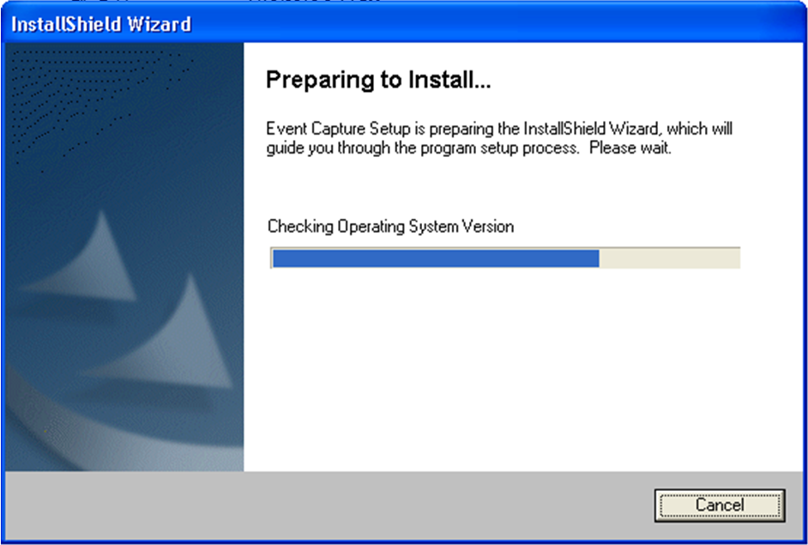

- When the Welcome to the InstallShield Wizard for Event Capture screen displays, click Next.

Example: Welcome to the InstallShield Wizard for Event Capture Screen

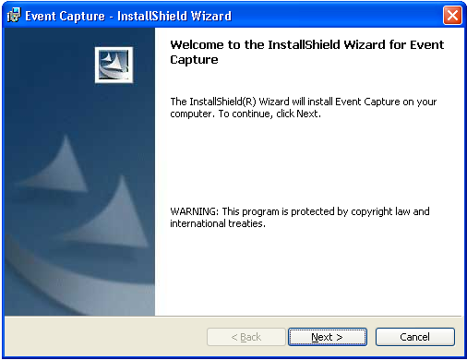

- On the Destination Folder screen, click Next to install to the default destination folder (C:\Program Files\VISTA\EC\). To install to a different folder, click Change.
Note: For WIN7, the installation creates the file in the ‘Program Files (x86)’ directory.

Example: Creating Destination Folder

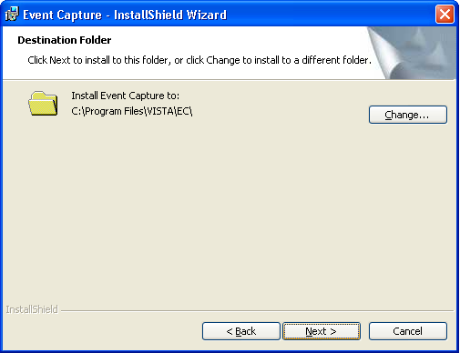

- Review the information on the Ready to Install the Program screen. If the information is correct, click Install. If changes are necessary, click Back.

Example: Ready to Install the Program for Event Capture

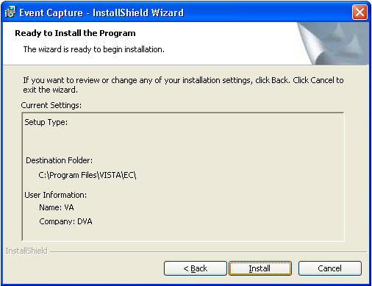

- The Installing Event Capture screen appears and shows the status of the install.

Example: Installing Event Capture Status screen

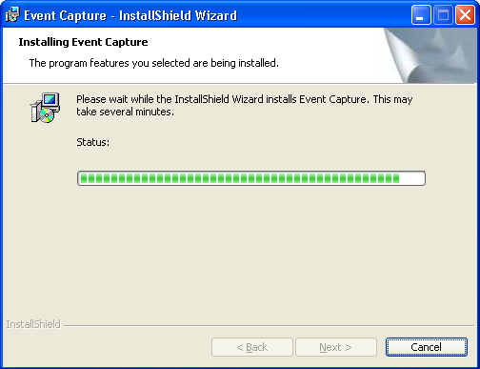

- The Install Wizard Completed screen appears when the install is complete. Click Finish. Event Capture will now be installed.

Example: Installing Event Capture Status screen

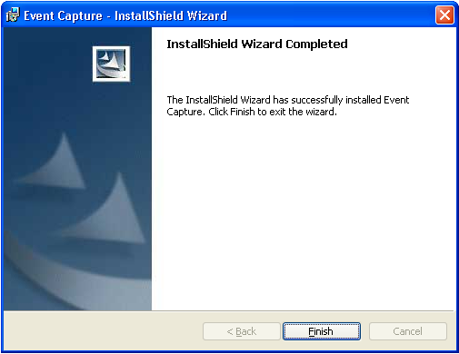

- Go to the Start menu and select All Programs. Select Event Capture and then ECS GUI.

Example: Accessing ECS GUI via Start Menu

- Right-click on the ECS GUI and select Properties.

Example: Selecting Properties



- After the file name (listed in Target), you will need to add the server (example: s=XXXX) and port (example: p=XXXX).
Note: Be sure to add one space before you add the server and port information.
Note: The server and port can be provided by your particular site. Without this information, Event Capture will not be able to run.

Example: Adding Server and Port to the Target Field



- Click Apply.
- The setup is complete. To create a shortcut on your desktop, right-click on the ECS GUI icon. Select Send To and the Desktop (create shortcut).



- Note for WIN7 users: For ECS GUI to operate the side scroll bar, the menu boxes may have to be in CLASSIC MODE. The WIN7 default puts framing around the GUI box that prevents you from scrolling up/down on certain report displays.

Accessing ECS GUI via CPRS
A “hot button” that will allow you to switch back and forth between the Computerized Patient Record System (CPRS) and ECS applications can be created in VistA by the site’s Clinical Coordinator. This button can either be created for a specific user or for all CPRS users. This button will be placed in the Tools menu of CPRS GUI so the user will have quick access to it within the application.

Instructions

Note: Parentheses denotes abbreviations that can be entered instead of entering the full name of the option.

- From the CPRS Configuration Menu for Clinical Coordinators, enter GUI Parameters (GP) at the prompt.
- From the list of options given, enter GUI Tool Menu Items (TM) at the prompt.
- From the list of options given, enter Package (9).
Note: By choosing this option you are giving this functionality to all users. If you want to give this functionality to one user choose User (1) instead.
- The user will receive two messages; one regarding the parameters set for ‘Package’ and the other for the Setting of the CPRS GUI Tools Menu for Package.
- The user will be asked to select a sequence. Type a question mark to get a choice of options.
- Enter a number higher than the last option to add a new option.
- When asked if you are adding a new option, enter YES.
- When prompted for a “Name=Command” enter: &Event Capture="c:\program files\vista\ec\ecs gui.exe"
- When asked to select a sequence again, press <Enter> to get out of prompt.
Example: Setting Up EC Option in the Tools Menu of CPRS GUI

AL Allocate OE/RR Security Keys
KK Check for Multiple Keys
DC Edit DC Reasons
GP GUI Parameters ...
GA GUI Access – Tabs,RPL
MI Miscellaneous Parameters
NO Notification Mgmt Menu ...
OC Order Checking Mgmt Menu ...
MM Order Menu Management ...
LI Patient List Mgmt Menu ...
FP Print Formats
PR Print/Report Parameters ...
RE Release/Cancel Delayed Orders
US Unsigned orders search
EX Set Unsigned Orders View on Exit
NA Search orders by Nature or Status
CA Care Management Menu ...
DO Event Delayed Orders Menu ...
LO Lapsed Order search
PM Performance Monitor Report

Select CPRS Configuration (Clin Coord) Option: GP GUI Parameters

CS GUI Cover Sheet Display Parameters ...
HS GUI Health Summary Types
TM GUI Tool Menu Items
MP GUI Parameters - Miscellaneous
UC GUI Clear Size & Position Settings for User
RE GUI Report Parameters ...
NV GUI Non-VA Med Statements/Reasons
EX GUI Expired Orders Search Hours
RM GUI Remove Button Enabled
NON GUI Remove Button Enabled for Non-OR Alerts
CLOZ GUI Edit Inpatient Clozapine Message
COAG GUI Anticoagulation Parameters ...
**> Out of order: On hold
EIE GUI Mark Allergy Entered in Error

Select GUI Parameters Option: TM GUI Tool Menu Items

CPRS GUI Tools Menu may be set for the following:

1 User USR [choose from NEW PERSON]
2 Location LOC [choose from HOSPITAL LOCATION]
2.5 Service SRV [choose from SERVICE/SECTION]
3 Division DIV [choose from INSTITUTION]
4 System SYS [PERF.ISC-BAYPINES.VA.GOV]
9 Package PKG [ORDER ENTRY/RESULTS REPORTING]

Enter selection: 9 Package ORDER ENTRY/RESULTS REPORTING

Parameters set for 'Package' may be replaced if ORDER ENTRY/RESULTS REPORTING is installed in this account.

-- Setting CPRS GUI Tools Menu for Package: ORDER ENTRY/RESULTS REPORTING --
Select Sequence: ?

Sequence Value
-------- -----
1 &Time=Clock.exe
2 &Calculator=Calc.exe
3 &Windows Introduction=WinHlp32 Wind
4 &Notepad=Notepad.exe

Select Sequence: 5
Are you adding 5 as a new Sequence? Yes// YES

Sequence: 5// 5
Name=Command: &Event Capture="c:\program files\vista\ec\ecs gui.exe"

For more information on this “tools” option, consult the CPRS user guide at:

http://www4.va.gov/vdl/application.asp?appid=61

This installation installs the GUI executable on the user’s workstation at location: C:\Program Files\VISTA\EC (unless another directory was specified on the “Choose Designation Location” screen). Using Windows or NT Explorer, go to the directory location of the executable (on the user’s workstation), create a Shortcut, and paste or copy it to the user’s Desktop for convenient access to the application.

If any prior versions of the applications exist on in the user’s directory location referenced above, these should be deleted.

